Project Design Phase-II

Data Flow Diagram & User Stories

|  |  |
| --- | --- |
| Date | 19 October 2022 |
| Team ID | PNT2022TMID37726 |
| Project Name | Customer Care Registry |
| Maximum Marks | 4 Marks |

# Data Flow Diagrams:

A Data Flow Diagram (DFD) is a traditional visual representation of the information flows within a system. A neat and clear DFD can depict the right amount of the system requirement graphically. It shows how data enters and leaves the system, what changes the information, and where data is stored.

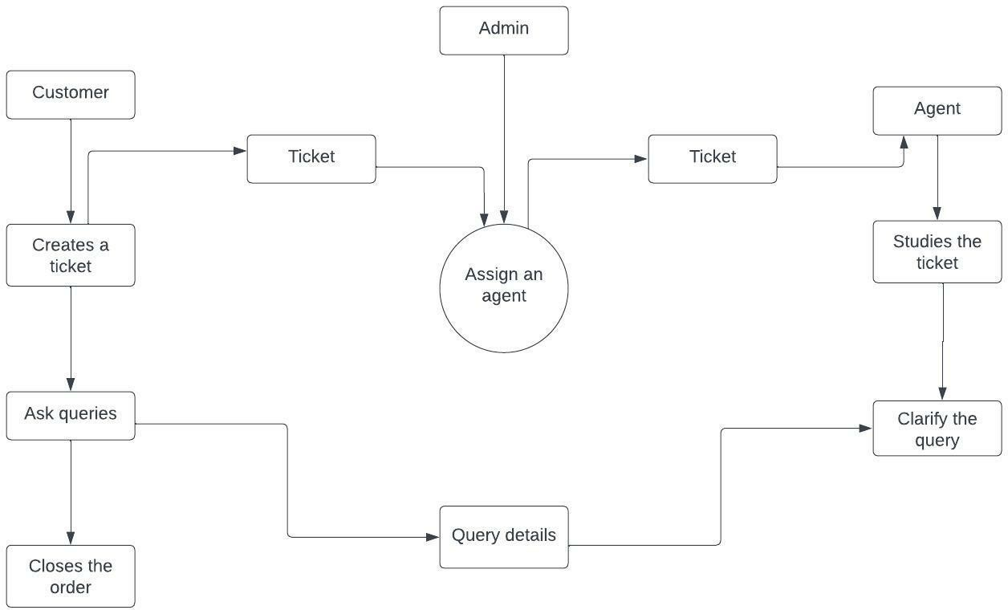

# User Stories

Use the below template to list all the user stories for the product.

|  |  |  |  |  |  |  |
| --- | --- | --- | --- | --- | --- | --- |
| **User Type** | **Functional Requirement (Epic)** | **User Story Number** | **User Story / Task** | **Acceptance criteria** | **Priority** | **Release** |
| Customer | Registration | USN-1 | As a user, I can register for the application by entering my email, password, and confirming  my password. | I can access my account / dashboard | High | Sprint-1 |
|  | Acknowledgement | USN-2 | As a user, I will receive confirmation email once I have registered for the application | I can receive confirmation email & click confirm | High | Sprint-1 |
|  | Ticket creation | USN-3 | As a user, I can create new tickets with  descriptions of my query. | I can create a ticket and  ask my query. | Medium | Sprint-2 |
|  | Forget password | USN-4 | As a user, I can reset my password by this option in case I forgot my password. | I can change the password | Medium | Sprint-1 |
|  | Login | USN-5 | As a user, I can login into the application by  entering email & password | I can access my account | High | Sprint-1 |
|  | Dashboard | USN-6 | As a user, I am able to see all the tickets raised by me. | I get all information in the dashboard | Low | Sprint-1 |
| Agent | Login | USN-1 | As an agent, I can login to the application by  entering the email id and password. | I can access my account | High | Sprint-2 |
|  | Forget password | USN-2 | As an agent, I can reset my password in case I forget my password | I can change my password | High | Sprint-2 |
|  | Dashboard | USN-3 | As an agent, I can able to see all the tickets  raised by the customers | I can see all the tickets  and clarify the queries | High | Sprint-2 |
| Admin | Login | USN-1 | As a admin, I can login to the application by entering email id and password | I can access my account | High | Sprint-3 |
|  | Agent creation | USN-2 | As a admin, I can able to create agent for the  customers to solve the queries | I can create agents | High | Sprint-3 |
|  | Forget password | USN-3 | As a admin, I can reset my password by this option in case I forgot my password | I can change password | Medium | Sprint-3 |
|  | Assigning Agent | USN-4 | As a admin, I can assign agents to the  customers who raised the tickets. | I can assign agents to the  customers | High | Sprint-3 |